**CPU Benchmarking**

* Strong scaling is performed by having the problem size in our case 10^9 * 24 fixed and varying the number of threads to execute( 1, 2, 4 ,8)
* 24 operations include addition, multiplication and division operations on integer / double precision floating point values are performed
* We have utilized - O2 optimization and ensured in assembly code that there are 24 operations being performed (can be verified in CPU/test.s assembly)
* Linpack bench mark being used is intel optimized binary and having a specific input given in CPU/linpack/lininput_xeon64

**Performance Results**

**1st run**

|  |  |  |
| --- | --- | --- |
|  | **IOPS** | **FLOPS** |
| **Threads - 1** | 2.3586 | 0.9548 |
| **Threads - 2** | 4.5063 | 1.8192 |
| **Threads - 4** | 4.4828 | 1.8218 |
| **Threads - 8** | 4.4278 | 1.9086 |

**2nd run**

|  |  |  |
| --- | --- | --- |
|  | **IOPS** | **FLOPS** |
| **Threads - 1** | 2.3182 | 0.9402 |
| **Threads - 2** | 4.5381 | 1.8644 |
| **Threads - 4** | 4.5645 | 1.8104 |
| **Threads - 8** | 4.4102 | 1.8044 |

**3rd run**

|  |  |  |
| --- | --- | --- |
|  | **IOPS** | **FLOPS** |
| **Threads - 1** | 2.2881 | 1.0423 |
| **Threads - 2** | 4.6758 | 1.9178 |
| **Threads - 4** | 4.7510 | 1.9064 |
| **Threads - 8** | 4.7415 | 1.9160 |

**Performance Graph (average of three execution results)**

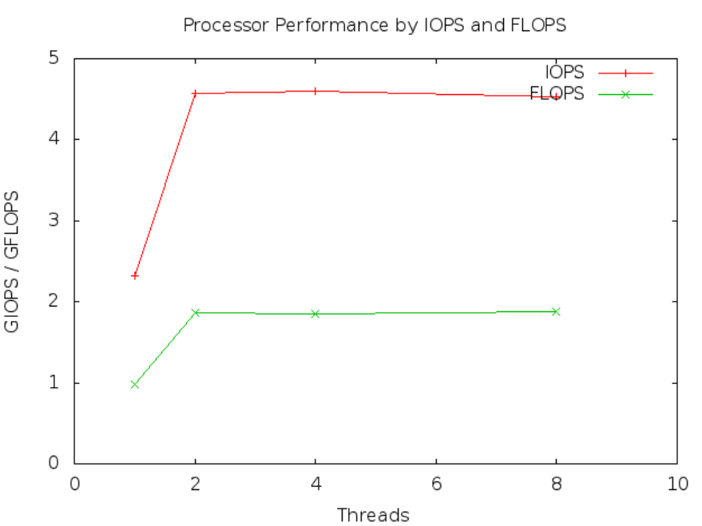

**Theoretical Peak Performance**

1. Intel Xeon E312xx (sandy bridge)

CPU speed: 2.3 GHz

Number of Cores: 1

Number of CPU’s: 2

Instructions per cycle: 8 CPI

Theoretical Peak Performance = (CPU Speed * No. of cores * Instructions per cycle * No. CPU’s)

= 2.3 * 1 * 8 * 2

= 36.8

Efficiency compared to theoretical performance = (GFLOPS / Theoretical Peak Performance ) * 100

= (1.9 / 36.8) * 100

= 5.16 %

1. Intel(r) Xeon (r) CPU E5-2670 v3 (formerly Haswell)

CPU speed: 2.3 GHz

Number of Cores: 12

Number of CPU’s: 2

Instructions per cycle: 16 CPI

Theoretical Peak Performance = (CPU Speed * No. of cores * Instructions per cycle * No. CPU’s)

= 2.3 * 12 * 16 * 2

= 883.2

**Linpack Bechmark Report (Intel Optimized Binary)**

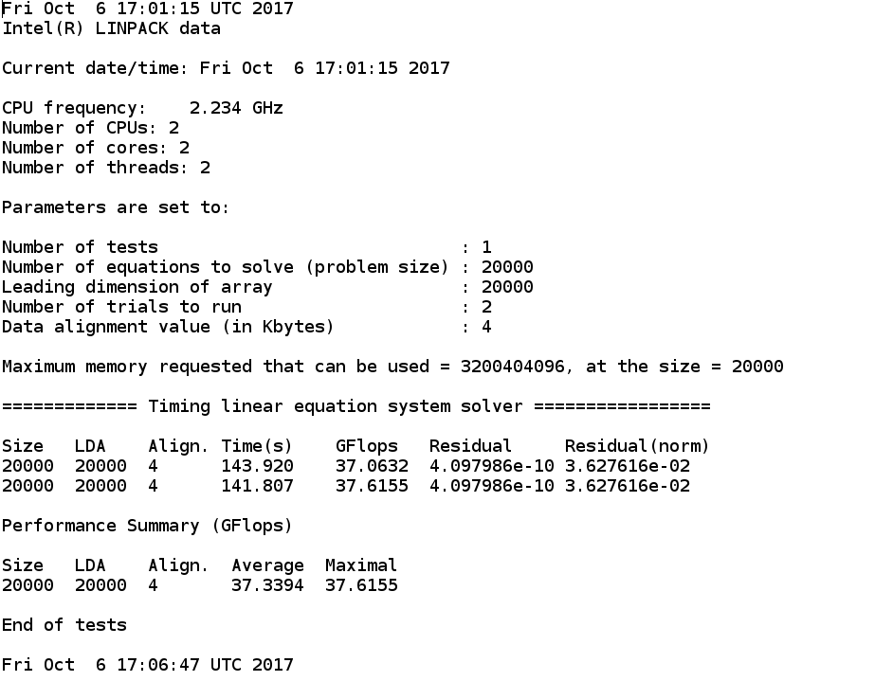

1. Efficiency compared to theoretical performance

Efficiency = (GFLOPS / Theoretical Peak Performance ) * 100

= (37.3 / 36.8) * 100

= 101 %

1. Efficiency of my code with respect to linpack

Efficiency = (GFLOPS / linpack GFlops ) * 100

= (1.9 / 37.3) * 100

= 5.09 %

Let's chat on Hangouts!

[https://github.com/stevenlysc/CS553_Assignment-1/blob/master/server_benchmark.c](https://www.google.com/url?q=https%3A%2F%2Fgithub.com%2Fstevenlysc%2FCS553_Assignment-1%2Fblob%2Fmaster%2Fserver_benchmark.c&sa=D&sntz=1&usg=AFQjCNFPwLfPet6lC7s0StsjQqUkAvCvmQ)

[https://github.com/stevenlysc/CS553_Assignment-1/blob/master/client_benchmark.c](https://www.google.com/url?q=https%3A%2F%2Fgithub.com%2Fstevenlysc%2FCS553_Assignment-1%2Fblob%2Fmaster%2Fclient_benchmark.c&sa=D&sntz=1&usg=AFQjCNFqxNGEBEJM0fNOYmGj5unJVnO1Rw)

Intel Xeon CPU E5-2670 v3

<https://ark.intel.com/products/81709/Intel-Xeon-Processor-E5-2670-v3-30M-Cache-2_30-GHz>

which being under haswell family has cpi of 16 for double precision and 32 for single precision according to

<https://en.wikipedia.org/wiki/Instructions_per_cycle#Calculation_of_IPC>

